Marta Sequeira

Postdoctoral Researcher at CIAUD, University of Lisbon / Research member at CHAIA, University of Évora / Assistant Professor at the University of Évora*

**Le Corbusier (1887-1965)**

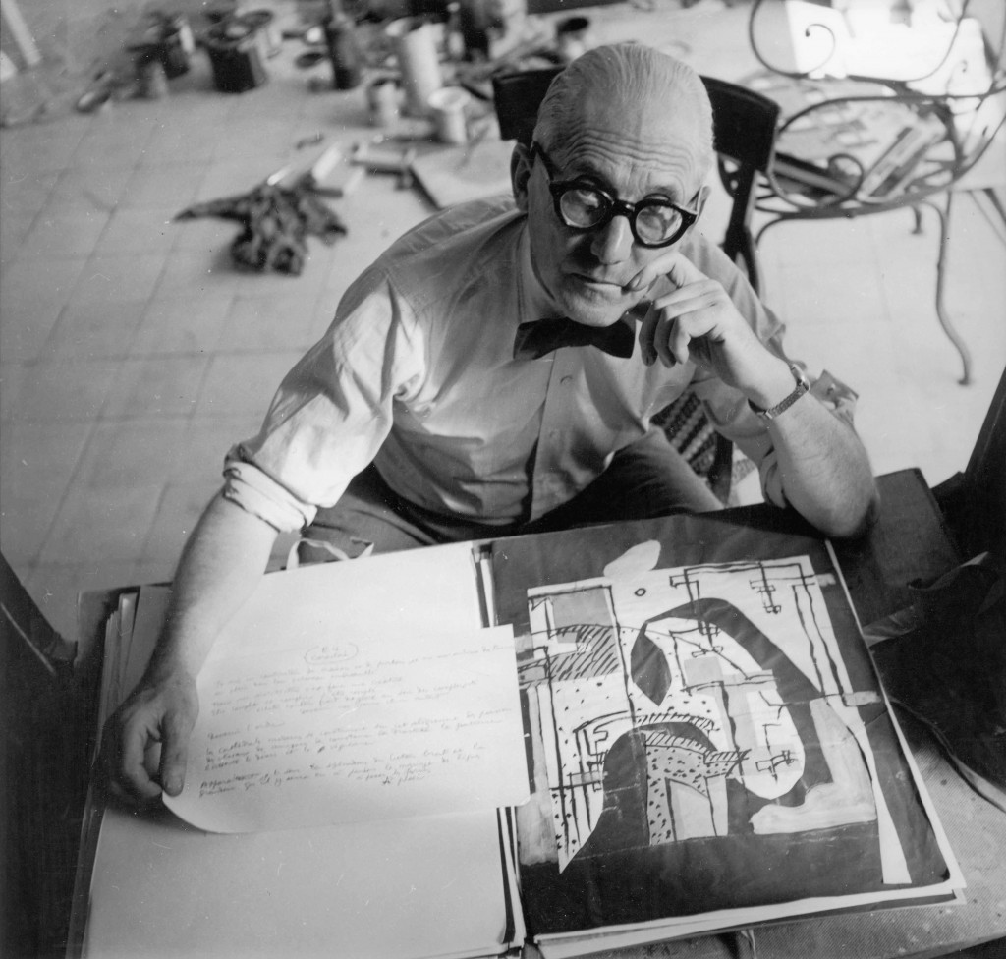Figure 1 – Le Corbusier, [circa 1945] (copyright: Heidi Weber)

<http://www.themodernist.co.uk/wp-content/uploads/2012/03/le-corbusier1-1024x976.jpg>

**Overview**

Le Corbusier was a Swiss architect and urbanist who acquired French nationality in 1930, having set up his studio (“the atelier of patient research”) in that country. Just as he assumed an unconditional continuity in relation to the past, he also clearly confronted the circumstances of his time. Many of his works became icons of Modernism, like the Villa Savoye (1928), the Marseilles Housing Unit (1945), the Ronchamp Chapel (1950), the Convent of Sainte-Marie de la Tourette (1953) and the Chandigarh Capitol Complex (1950-55), to mention just a few examples. His architecture reflected the development of a modern industrialized economy, a western avant-garde culture and a vibrant political and social context. He made a mark not only with his constructed work, but also with designs that were never built (and which were progressive in character), his painting (which reflected his experimentalist nature) and with his theoretical texts, which today bear witness to his modernist doctrine. Le Corbusier was above all one of the most prolific thinkers of Modernism, and one of the greatest cultural figures of the 20th century.

**Early years and education (1987-1917)**

Le Corbusier was born Charles-Édouard Jeanneret, on 6th October 1887 in La Chaux-de-Fonds, in the canton of Neuchatel in Switzerland to an artistic family. His father was a watch engraver, his mother a piano teacher and his older brother became a musician. He studied at the Arts School at La Chaux-de-Fonds, and there decided to be an architect, through the influence of his teacher Charles L’Eplattenier.

At 17 years of age, he began his first project, the Villa Fallet at La Chaux-de-Fonds. Then, at 19, he embarked on a series of trips which served as a kind of initiation into the world of architecture. He travelled for two and a half months around Italy, passing through Lombardy, Liguria, Tuscany, Emilia Romagna and Venetia, and stayed in Vienna for four months, where he had the chance to meet JOSEF HOFFMANN, KOLOMAN MOSER and GUSTAVE KLIMT. He also stayed in Paris for around a year, where he met Jourdain, Plumet, Sauvage and Grasset. There he divided his days between the atelier of the Perret brothers and his research at the National Library of France. At 22, he returned to La Chaux-de-Fonds for a short spell, where he constructed the Stotzer and Jacquemet villas and founded the Ateliers d’Arts Réunis; but he soon set off again on a mission (awarded by the La Chaux-de-Fonds Art School), this time to Germany, where he worked for around five months with PETER BEHRENS. At 23, he made his so-called “Journey to the East”, around the Danube, Balkans, Constantinople, Greece and Italy.

At 24, he returned to La Chaux-de-Fonds, where he managed a new section of the Art School for three years with Charles L’Eplattenier. There he planned the Jeanneret-Perret, Favre-Jacot and Schwob villas, as well as the La Scala cinema. He also began the study for the “Dom-Ino” House, a solution that used reinforced concrete slabs and pillars, and where the dividing partitions were non load-bearing (inaugurating what he would call the “free plan”).

At 30, Jeanneret left his native city and settled definitively in Paris.

**First period (1917-1940)**

In 1918, through AUGUSTE PERRET, Jeanneret met Amédée Ozenfant (the painter that introduced him to Contemporary Art and Purism, and with whom he had his first exhibition), as well as BRAQUE, GRIS, PICASSO, Lipchitz, and others. In 1920, for his articles in the magazine *L’Esprit Nouveau*, which he founded with Amédée Ozenfant and Paul Dermée, he adopted the pseudonym of Le Corbusier, after his maternal grandfather, Lecorbesier – this was meant to be reminiscent of the French for "crow": corbeau. In 1922, at 35, he finally installed himself in the studio on Rue de Sèvres with his cousin and partner Pierre Jeanneret.

In 1922, in the Salon d’Automne in Paris, he first showed his designs for a house (the Citrohan House), a collective housing project (the Villas-apartments or “Immeuble-villas”) and a plan for a city (the “Contemporary city of three million inhabitants”). These three projects together effectively laid the foundations for his architectural plans in this first period of activity, which lasted until 1940.

In the 1920s, he developed some collective housing projects, but only got round to building some of them in the 1930s (such as the Clarté Apartment-house in 1930 and the Molitor Apartment-house in 1931-34). Although he was very interested in constructing collective working-class housing (in 1924 he built his Maisons Ouvrières in Lège, and in 1925, the Quartiers Modernes Frugès in Pessac), he built many houses for élite private clients in the 1920s, such as the House and Studio of the painter Amédée Ozenfant (1922), La Roche-Jeanneret Houses (1923-25), Cook House (1926), Villa Stein-de-Monzie (1926) and Villa Savoye (1928). In these houses, he attempted to implement his principles, the “five points for a new architecture”: the *pilotis*, roof garden, free plan, long window and the free façade.

Though he spent most of the 1920s building villas, in the 1930s, after the controversial Plan Voisin for Paris (1925), he concentrated primarily upon a series of urbanistic projects that derived from the Radiant City (1930). They go against the concentric city, proposing a city without limits, and thus without a periphery. His design seemed to be able to grow infinitely in accordance with the growing population and economy. In that decade, he planned many new cities, such as Nemours (1933) and Hellocourt (1935), as well as reclaiming or extending existing cities, such as Antwerp (1933), Barcelona (1933), Stockholm (1933), and even Algiers (1930) and Zlin (1935).

During this first period, he also entered competitions, such as the controversial contest for the Palace of the League of Nations in Geneva (1927), and planned some remarkable buildings that were never built, such as the Ministry of National Education and Public Health in Rio de Janeiro (1936), the 1000-seat Stadium in Paris (1936) and the Museum of Unlimited Growth (1939). However, he also constructed some emblematic buildings, such as the Centrosoyus Building in Moscow (1928), the Salvation Army Refuge in Paris (1929), the Swiss Pavilion at the Paris University Campus (1930) and the Pavilion des Temps Nouveaux in Paris (1936).

During this period, Le Corbusier gave many lectures and travelled frequently through France, Switzerland, Spain, Belgium, Sweden, Norway, Germany, Czechoslovakia, the Soviet Union, the United States, Argentina, Uruguay, Brazil, Morocco and Algeria. These trips continued to feed his creative imagination, just as they did in his youth.

**The war years (1940-1945)**

One year after Le Corbusier published *Cannons? ammunition? No Thanks! Housing please…* (*Des canons? Des munitions? Merci, des logis S.V.P....*,1938), France declared war on Germany. Le Corbusier left Paris in June 1940, and headed for Ozon in the Pyrenees with his wife, Yvonne Gallis, and his cousin Pierre Jeanneret. He stayed for some time in Vichy, painting, writing and reflecting. He designed building systems ranging from adobe walls, like those used in the Murondin Houses (1940), and prefabricated parts, as used in the Maisons Montées à Sec (1940). From 1943, with the support of a collaborator, Gerald Hanning, he created the Modulor, which consisted of an outline based on a double square, the Fibonacci series and golden ratio, from which it would be possible to generate two measurement scales in harmony with the human body and amongst themselves. Its application in the post-war period would enable him to unite the world of construction, which till then had been divided into two parts: metres and centimetres, and feet and inches.

**Second period (1945-1965)**

When the war finished, Le Corbusier was 57 years old and ready to help reconstruct Europe after the destruction of war. He drew up various projects for housing units (“*unités d’habitation*”), mostly on French territory. They included Rezé-lès-Nantes (1952), Briey-en-Forêt (1956) and Firminy (1960), but most of all Marseilles (1945). On robust *pilotis* (stilts), 8 metres from the ground, there is an “artificial floor” which serves technical purposes. On this ideal terrain he placed a reticulated alveolar structure in reinforced concrete incorporating 337 cells, which could accommodate 1600 people. The two most common types of apartments are the “duplex” type, slotted into one another so as to create an opening at the centre that forms one of five “indoor streets”. Half way up the building on the 7th and 8th floors is a market, and on the top floor a crèche. At the very top, in the open air, is the place that Le Corbusier called his “roof terrace” (“*toit-terrasse*”), where there is a series of facilities designed for collective use, for the cultivation of the body and mind.

Le Corbusier also drew up plans for various French cities that had been devastated by the war, redesigning and refurbishing them in order to rehouse a significant portion of the population. They included the projects for Saint-Gaudens (1945), La Rochelle-La Pallice (1945), Vieux-Port Marseilleveyre (1945) and Marseille Sud (1946), but above all Saint-Dié (1945). This depicts a residential zone north of the river, composed of 4 to 8 collective housing buildings of the *unité d’habitation* type, designed for 1600 inhabitants each. In the south, for around 1200 metres, is the industrial zone, designed in accordance with the principles of the “green factory” (“*usine* *verte*”). The city stretches in two bands in an east-westerly direction without limits, and therefore does not have a periphery. In the middle is the public space that Le Corbusier called the “civic centre” (“*centre* *civique”)* or “heart of the city“(“*cœur de la ville”*).

But in addition to reconstruction works, Le Corbusier was also engaged with constructing the new world. Both environments allowed him to build in an atmosphere of haste and productive urgency, which was highly fruitful to his architectural and urbanistic ideals. In 1950, he was appointed Planning Advisor to the Government of Punjab, responsible (with Pierre Jeanneret, MAXWELL FRY and JANE DREW) for the design of its new capital, where his urbanistic principles were applied on the scale of the metropolis. This launched a period of strong relations with India, when he built not only buildings for the Capitol of Chandigarh – the Court of Justice (1952), Secretariat (1953) and Palace of the Assembly (1955) – but also the Hutheesing-Shodhan Villa (1951), Madame Manorama Sarabhai’s Villa (1951), the Museum of Ahmedabad (1951), Museum of Chandigarh (1952) and the Mill Owners’ Association Building (1951), which reflected a strong relationship with the countryside, climate and monumental scale. The great formal variety of these buildings was achieved by taking advantage of the malleability of concrete, often displaying concave and convex forms. Concrete had now clearly transcended its functional role and become a flexible material, achieving a peak of sumptuousness with the hyperbolic-paraboloid shells of the Philips Pavilion (1958), created for the international exhibition in Brussels.

In the 1950s, Le Corbusier also designed the two religious buildings most emblematic of his mature style: the Chapel of Notre Dame du Haut in Ronchamp (1950) and the Convent Sainte-Marie de La Tourette (1953). While the chapel seems to defy his modern principles, rising up through thick rugged walls topped with a convex roof, the concrete convent seems to recreate the Cistercian cloister of Thoronet, with its profusely occupied centre.

Amongst the types used by Le Corbusier during this period, there are also museums, such as the National Museum of Fine Arts of the West in Tokyo (1957), and the Museums of Chandigarh (1952) and Ahmedabad (1951), mentioned above. These buildings were all based on the museums of unlimited extension that he had designed in the 1930s: raised off the ground with blind façades, zenithal lighting, a square spiral ground plan and the tendentially unlimited possibility for growth.

On 27th August 1965, at 11 o’clock in the morning, Le Corbusier died while bathing in the sea near his cottage at Roquebrune-Cap-Martin, where he usually spent his summer holidays. He left behind a series of unfinished projects which nevertheless form a huge legacy (such as the Hospital of Venice, the Church at Firminy, and the Olivetti Electronic Calculation Centre). In these, natural lighting and circulation were the main protagonists of the space.

In addition to his 215 unbuilt projects, Le Corbusier left around 78 built works in countries such as France, Switzerland, Belgium, Germany, Russia, Iraq, Tunisia, the United States, Argentina, India and Japan. He also left around 250 works of art, 20 pieces of furniture and above all a powerful theoretical legacy, broadly divulged through his writings. A considerable number of the architects that passed through his studio on the Rue de Sévres went on to become equally great architects themselves (e.g. Josep Luis Sert of Spain, ÓSCAR NIEMEYER from Brazil and CHARLOTTE PERRIAND from France, to name but a few), and many were his admirers and followers.

**Writings**

Le Corbusier always liked to proclaim his discoveries, and from early on developed a strategy for disseminating his work and thought through writing. He published 47 books and over 400 articles in various publications, and there are various books published about his work to which he contributed. Even so, these texts constituted only a small part of his publishing projects, for many of which did not see the light, for various reasons. His most significant books included *Vers une architecture* (1923*)*, *Urbanisme* (1925), *Une maison, un palais* (1928), *Précisions sur un état présent de l’architecture et de l’urbanisme* (1930), *La Ville radieuse* (1935), *Quand les cathédrales étaient blanches* (1937), *Sur les 4 routes* (1941), *La maison des hommes* (1942), *La Charte d’Athènes* (1943), *Les Trois établissements humains* (1945), *Manière de penser l’urbanisme* (1946), *Propos d’urbanisme* (1946), *Le Modulor* and *Modulor 2* (1950 and 1955), *Poème de l’angle droit* (1955) and *Œuvre complète* 1934-1965). He also tried to ensure that his works were published in as many different languages as possible; indeed, some of his texts were translated while he was still alive into languages such as German, English, Spanish, Italian, Czech, Polish, Bosnian, Dutch and Swedish. As Françoise Choay claimed in *La Règle et le Modèle*, his œuvre is perhaps “the most abundant, widespread and the most widely read of all urbanistic literature”.

**Built works**

Selective list:

1905 Villa Fallet (La Chaux-de-Fonds, Switzerland)

1907 Villa Jacquemet (La Chaux-de-Fonds, Switzerland)

1907 Villa Stotzer (La Chaux-de-Fonds, Switzerland)

1912 Villa Jeanneret-Perret (La Chaux-de-Fonds, Switzerland)

1912 Villa Favre-Jacot (Le Locle, Switzerland)

1916 Villa Schwob (La Chaux-de-Fonds, Switzerland)

1916 La Scala cinema (La Chaux-de-Fonds, Switzerland)

1922 House and Studio of the painter Amédée Ozenfant (Paris, France)

1923 La Roche-Jeanneret Houses (Paris, France)

1923 Villa Le Lac (Corseaux, Switzerland)

1924 Pavilion de L’Esprit Nouveau (Paris, France)

1925 Quartiers Modernes Frugès (Pessac, France)

1926 Cook House (Boulogne-sur-Seine, France)

1926 Villa Stein-de-Monzie, “Les Terrasses” (Garches, France)

1928 Villa Savoye (Poissy, France)

1928 Centrosoyus (Moscow, Russia)

1929 Salvation Army Refuge (Paris, France)

1930 Swiss Pavilion at the Paris University Campus (Paris, France)

1930 Clarté Apartment-house (Geneva, Switzerland)

1931 Molitor Apartment-house (Paris, France)

1936 Pavilion des Temps Nouveaux (Paris, France)

1945 Housing Unit (Marseille, France)

1949 Cabanon (Roquebrune-Cap-Martin)

1950 Chapel of Notre Dame du Haut (Ronchamp, France)

1951 Mill Owners’ Association Building (Ahmedabad, India)

1951 Madame Manorama Sarabhai’s Villa (Ahmedabad, India)

1951 Hutheesing-Shodhan Villa (Ahmedabad, India)

1951 Jaoul Houses (Neuilly-sur-Seine, France)

1951 Museum of Ahmedabad (Ahmedabad, India)

1952 Museum of Chandigarh (Chandigarh, India)

1952 Court of Justice (Chandigarh, India)

1953 Secretariat (Chandigarh, India)

1953 Convent Sainte-Marie de La Tourette (Eveux-sur-l’Abresie, France)

1955 Palace of the Assembly (Chandigarh, India)

1957 National Museum of Fine Arts of the West (Tokyo, Japan)

1958 Philips Pavilion (Brussels, Belgium)

See complete list at:

http://www.fondationlecorbusier.fr/corbuweb/morpheus.aspx?sysName=list&sysLanguage=en-en&sysParentId=64&sysParentName=home&itemId=4445&itemPos=1&itemCount=78&itemSort=en-en_sort_date1

**Unbuilt projects**

Selective list:

1914 Dom-Ino House (not located)

1922 Immeuble-villas (not located)

1922 Citrohan House (not located)

1922 Contemporary city of three million inhabitants (not located)

1925 Plan Voisin (Paris, France)

1927 Palace of the League of Nations (Geneva, Switzerland)

1930 Palace of the Soviets (Moscow, Russia)

1930 Radiant City (not located)

1936 1000-seat Stadium (Paris, France)

1936 Ministry of National Education and Public Health (Rio de Janeiro, Brazil)

1939 Museum of Unlimited Growth (not located)

1940 Maisons Montées à Sec (not located)

1940 Murondin Houses (not located)

1945 Saint-Dié (Saint-Dié, France)

1945 The Modulor (not located)

1950 Governor's Palace (Chandigarh, India)

1950 Capitol (Chandigarh, India)

1950 Chandigarh (Chandigarh, India)

1963 Olivetti Electronic Calculation Centre (Rho, Italy)

1964 Hospital of Venice (Venice, Italy)

See complete list at:

http://www.fondationlecorbusier.fr/corbuweb/morpheus.aspx?sysName=list&sysLanguage=en-en&sysParentId=65&sysParentName=home&itemId=5924&itemPos=1&itemCount=215&itemSort=en-en_sort_date1

**Video clips**

Le Corbusier, interviewed by Jean-Marie Drot (broadcast date: March 28, 1958; copyright: Institut National de l’Audiovisuel):

http://www.ina.fr/video/I05290951

Le Corbusier, interview (broadcast date: June 5, 1960; copyright: Institut National de l’Audiovisuel):

http://www.ina.fr/video/CPF86607051

Le Corbusier, interview (broadcast date: December 5, 1987; copyright: Institut National de l’Audiovisuel):

http://www.ina.fr/video/POC8712072112

**Audio clips**

Le Corbusier, interviewed by Georges Charbonnier (broadcast date: July 9, 1953; copyright: Institut National de l’Audiovisuel):

http://www.ina.fr/audio/PHD86056263

**References and further reading**

Benton, Tim; Cohen, Jean-Louis (2008) *Le Corbusier, le grand*. London, New York: Phaidon.

Boesiger, Willy (1960), *Le Corbusier 1910-65*. Zurich: Girsberger.

Choay, Françoise (1960), Le Corbusier. New York: George Braziller.

Cohen, Jean-Louis (2005) *Le Corbusier. La planète comme chantier*. Paris: Textuel; [Genève]: Zoé.

Cohen, Jean-Louis (ed.) (2013) *Le Corbusier: An Atlas of Modern landscapes*. New York: The Museum of Modern Art.

Torres Cueco, Jorge (2004) *Le Corbusier. Visiones de la técnica en cinco tempos*. Barcelona: Fundación Caja de Arquitectos

Curtis, William (1986) *Le Corbusier: ideas and forms*. New York: Rizzoli.

Frampton, Keneth (2001) *Le Corbusier*. Thames & Hudson.

Gans, Deborah (1987) *The Le Corbusier Guide*. Princeton NJ: princeton Architectural press.

Gauthier, Maximillien (1944) *Le Corbusier ou l’architecture au service de l’homme*. Paris: Éditions Denoël.

Jencks, Charles (1973) *Le Corbusier and the Tragic View of Architecture.* Cambridge, Mass: Harvard University Press

Jencks, Charles (2000) *Le Corbusier and the Continual Revolution in Architecture.* New York: Monacelli Press

Jenger, Jean (1990) *Le Corbusier un autre regard.* Paris: Éditions Connivences.

Le Corbusier (1943) *Entretien avec les Étudiants des Écoles d’Architecture*. Paris: Denoel.

Le Corbusier (1948) *New World of Space*. New York: Reynal and Hitchcock

Le Corbusier (1960) *Le Corbusier (l’atelier de la recherche patiente).* Paris, Éditions Vincent Fréal.

Le Corbusier (1966) *Mise au point.* Paris: Éditions Forces Vives.

Lucan, Jacques (ed.) (1987) *Le Corbusier: une encyclopédie: ouvrage publié à l’occasion de l’exposition “L’aventure Le Corbusier”.* Paris: Centre Georges Pompidou, CCI.

Monnier, Gérard (1999) *Le Corbusier.* Tournai: La Renaissence du livre.

Monteys, Xavier (1996) *La gran máquina. La ciudad en Le Corbusier*. Barcelona: Ediciones del Serbal.

Moos, Stanislaus von (1979) *Le Corbusier, elements of a synthesis*. Cambridge, Mass.; London: MIT Press.

Weber, Nicholas Fox (2008) *Le Corbusier: A Life*. New York: Alfred A Knopf.

*The author wishes to acknowledge the Portuguese funding institution FCT - Fundação para a Ciência e a Tecnologia for supporting her research.

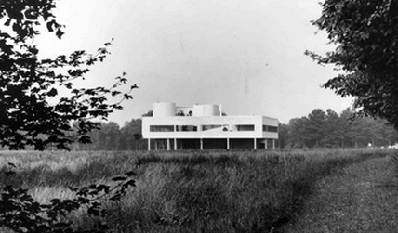

Figure 2 – Villa Savoye, 1928 (copyright: FLC/ADAGP L2 17 8)

<http://www.domes-architecture.com/pics/issue/0107/0107_naegele02.jpg>



Figure 3 – Marseilles Housing Unit, 1945 (copyright: FLC/ADAGP L1 13 6)

<http://ad009cdnb.archdaily.net.s3.amazonaws.com/wp-content/uploads/2012/04/1334006083-01-corbusier-unite01.jpg>

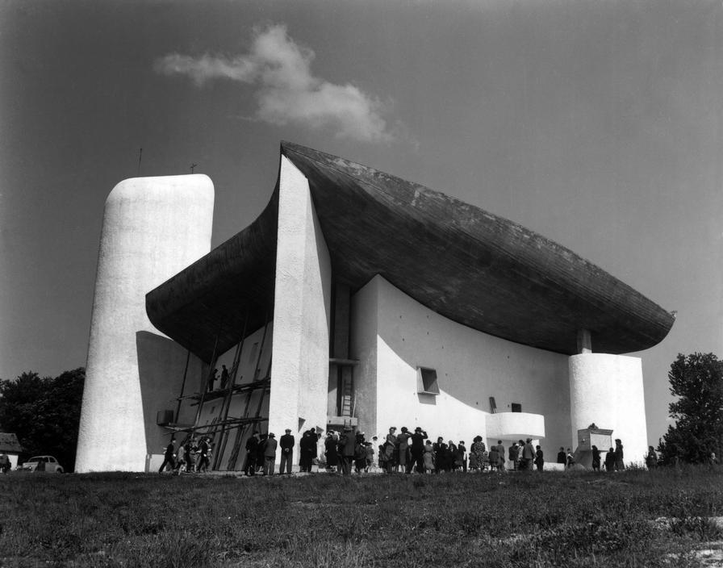

Figure 4 – Ronchamp Chapel, 1955 (copyright: Rene Burri/Magnum Photos)

<http://www.magnumphotos.com/CorexDoc/MAG/Media/TR2/4/e/d/7/PAR264045.jpg>

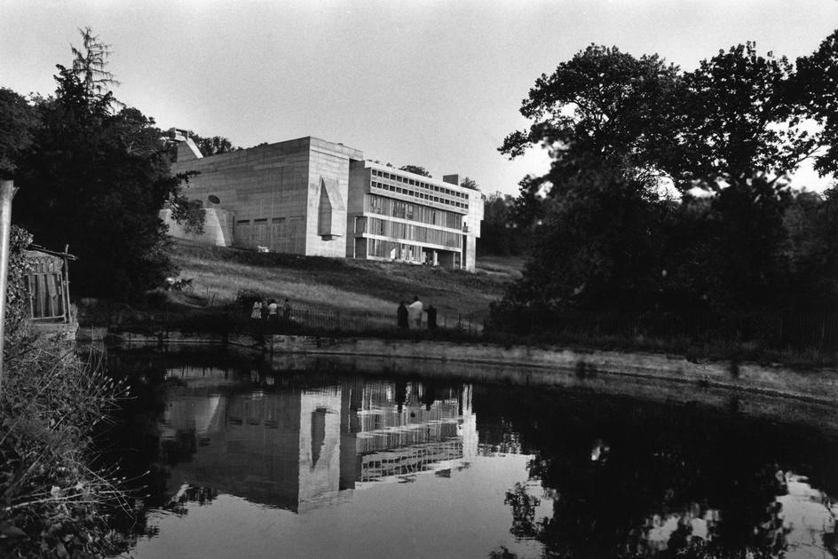

Figure 5 – Convent of Sainte-Marie de la Tourette, 1959 (copyright: Rene Burri/Magnum Photos)

<http://www.magnumphotos.com/CorexDoc/MAG/Media/TR2/5/4/1/d/PAR163050.jpg>

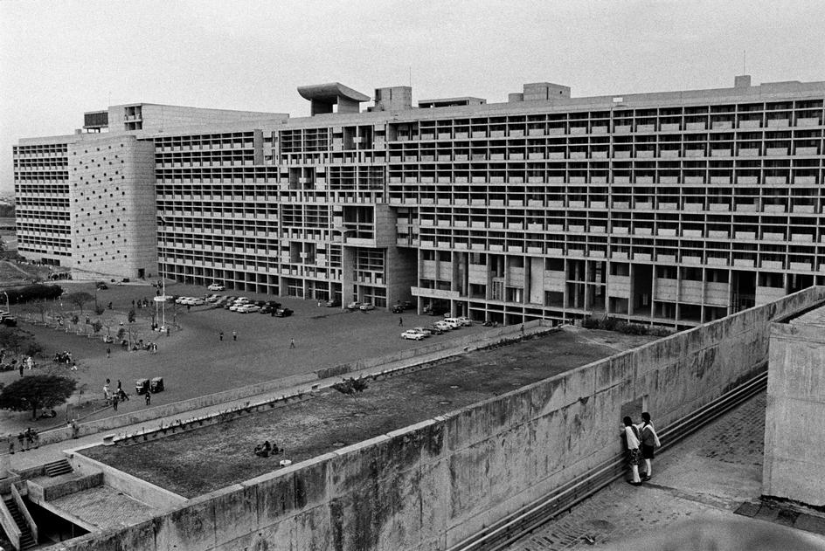

Figure 6 – Chandigarh Capitol Complex, 1970 (copyright: Rene Burri/Magnum Photos)

<http://www.magnumphotos.com/CorexDoc/MAG/Media/TR2/0/2/f/e/PAR322934.jpg>